2.0 Literature review

2.1 Anatomy of the urinary bladder

The upper urinary tract and lower urinary tract are divided into two segments for explanatory purposes. The lower urinary system is a combination of the urinary bladder and urethra, meanwhile the former is made up of the kidneys and ureters (Mahadevan, 2016).

Men have an intrapelvic bladder that only elevates above the pubis when it is pathologically dilated. The bladder neck in a juvenile is aligned to the anterior symphysis pubis. The prostate is a chestnut-sized, pyramid-shaped organ. The ejaculatory ducts, which separate the small median lobe from the center of the gland, and the prostatic portion of the urethra flow through it (Ellis, 2005).

The storage of urine as well as its periodic emission are the two main roles of the lower urinary tract. A sophisticated neural control system in the brain and spinal cord controls these mechanisms. To maintain a reciprocal relationship between the urinary tract's reservoir (the bladder) and exit (the urethra and urethral sphincter), this control system acts as a fundamental switching circuit (de Groat, 1993).

The bladder, urethra, and prostate are all parts of the lower urinary tract in males. Both the involuntary storage of urine produced in the upper urinary tract and the voluntary evacuation of urine at the proper time and location require these organs. Functional conditions like hyperactive bladder, urine incontinence, and bladder outlet obstruction brought on by enlarged prostates are frequent, as are prostate and bladder cancer (Patel & Chapple, 2008). 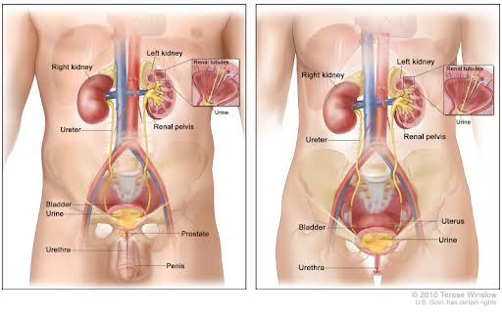

2.1.1 Developmet of the bladder

The primitive urogenital sinus, which is formed after the cloaca is divided, gives rise to the bladder and ureterovesical junction, which develops largely between weeks four and eight of pregnancy. The endoderm of the urogenital sinus and mesodermal mesenchyme interact with the epithelium to form the bladder. The Wolffian duct and the bladder interact to create the ureterovesical junction. The Wolffian duct gives rise to the ureteric bud, which is integrated into the growing bladder at the trigone. It has been demonstrated that bladder mesenchyme is where the trigonal musculature develops from most often than the Wolffian duct, contrary to earlier belief (Liaw et al., 2018)

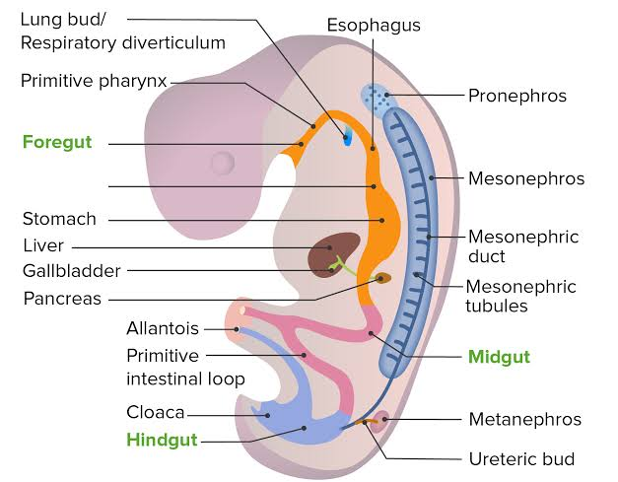

2.1.2 Musculature of the bladder

At the bladder neck, there are two muscles that act as sphincters: one is voluntary, the other is involuntary, and they are spaced at least an inch apart. The development of the ejaculatory ducts in between them explains the existence of this dual musculature. When semen is released, if both of these muscles are open, secretion may escape into the bladder or to the outside, and any urine in the bladder would also flow out. During ejaculation, the internal sphincter normally relaxes strongly (MacAlpine, 1934)

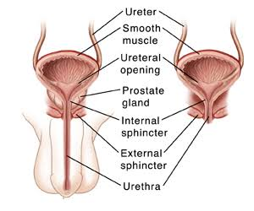

2.1.3 Neurovasculature of the bladder

With its thoracodorsal nerve coaptated to the lowest branch of the intercostal nerve, the LDM is partially wrapped around the acontractile bladder. Following the reinnervation of the LDM, rectus abdominis and transplanted latissimus muscles activate simultaneously, causing the bladder to be voluntarily emptied. The nerve coaptation promotes a synergistic function of both muscles since the contraction of both muscles increases the intravesicular pressure (Ninkovic et al., 2012)

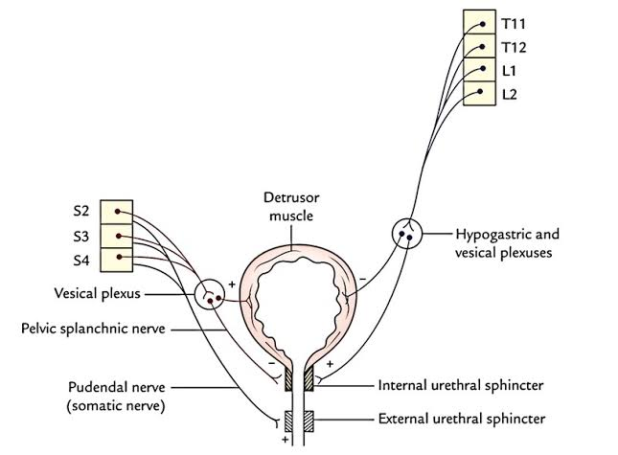

2.1.4 Epithelial lining of the bladder

The lower urinary tract's primary function is to temporarily store and then occasionally remove urine from the bladder. For this, a sophisticated brain control system must coordinate the striated muscles of the pelvic floor and outflow region with the smooth muscles of the bladder and urethra. Afferents in the hypogastric and pudendal nerves, as well as lumbrosacral afferent fibers (pelvic afferents), are crucial for controlling the mechanisms for continence and micturition. Afferent nerves have been found in the detrusor muscle and suburothelially in the bladder (Jost et al., 1989).

They create a plexus suburothelially that is located directly below the epithelial lining. The trigone and bladder neck have unusually dense areas of this plexus. Myelinated A-fibers and unmyelinated C-fibers are the two main afferents in the micturition process (Newman & Hicks, 1981).

Numerous peptides, including substance P, calcitonin gene-related peptide, vasoactive intestinal polypeptide, enkephalins, and cholecystokinin, are localized either alone or in combination in afferent pathways of the bladder and urethra, according to immunocytochemical and tracing investigations (Carvalho et al., 2006).

These nerves contain vanilloid, purino, tachykinin, and prostanoid receptors among others. It has been discovered that extracellular adenosine triphosphate (ATP) mediates the activation of small-diameter sensory neurons via P2X3 receptors (Martin, 1972). It has also been hypothesized that bladder distention triggers the release of ATP from the urothelium. In turn, ATP can trigger a neuronal discharge by activating P2X3 receptors on suburothelial afferent nerve terminals. However, it is most likely that ATP is also a part of the transduction mechanisms underpinning the activation of afferent fibers during bladder filling, in addition to a cascade of inhibitory and stimulatory transmitters/mediators (Andersson, 2002).

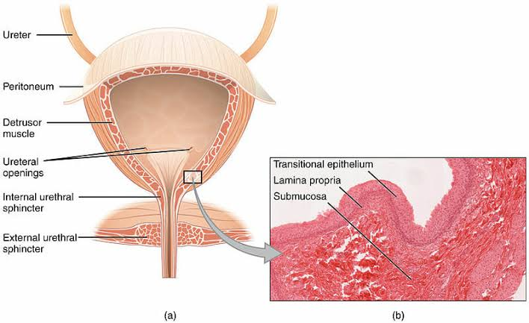

2.2 Bladder cancer

For both men and women, bladder cancer ranks as the fourth most prevalent type of cancer. Bladder cancer can range from noninvasive, mostly nonaggressive tumors that return and subject patients to long-term invasive surveillance to invasive, highly lethal tumors (Lenis et al., 2020)

Bladder cancer is primarily caused by cigarette smoking, advanced age, and male sex. Depending on the degree of hematuria and risk of malignancy, bladder tumors can appear with either gross or microscopic hematuria, which is assessed using cystoscopy and upper tract imaging. Depending on the risk level, endoscopic resection and adjuvant intravenous therapy are used to treat non-muscle-invasive cancers (Lenis et al., 2020)

If not properly treated, bladder cancer is a difficult condition with significant rates of morbidity and fatality. The key to a successful outcome is early identification, individualized treatment, and follow-up. Haematuria should be recognized as the primary presenting symptom (Kamat et al., 2016).

Painless haematuria is the primary presenting symptom of all bladder malignancies, and urine cytology and transurethral tumour removal are used to confirm the diagnosis. Carcinoma in situ and other high grade, non-muscle-invasive tumors are treated intravenously. In some circumstances, bladder preservation with transurethral tumour excision, radiation therapy, and chemotherapy can be equally effective. Numerous chemotherapeutic drugs have demonstrated efficacy in patients with metastatic illness and as neoadjuvant or adjuvant therapy (Kaufman et al., 2009).

The main risk factors for bladder cancer are exposure to carcinogens at work or in the environment, particularly tobacco. Patients with macroscopic haematuria are typically the first to be identified with bladder cancer, and cases are confirmed via transurethral resection of bladder tumors (TURBT), which also acts as the initial stage of therapy (Sanli et al., 2017).

The methods for diagnosing and treating localized and advanced disease have changed as a result of advances in our understanding of the molecular biology and genetics of bladder cancer. The standard of care for intermediate- and high-risk non-muscle-invasive bladder cancer remains intravesical BCG, but the range of treatment options for muscle-invasive and advanced disease has increased to include immunotherapy with checkpoint inhibition, targeted therapies, and antibody-drug conjugates (Raghavan et al., 1990).

2.2.1 Classification of bladder cancer

A variety of malignancies, including those that are (1) papillary in nature and restricted to the mucosa, (2) high grade and flat and restricted to the epithelium, and (3) invasive into the submucosa, or lamina propria, make up the category of superficial "non-muscle-invasive" bladder tumors (Pasin et al., 2008).

2.2.1.1 Muscular invasive

Muscle-invasive bladder cancer (MIBC) has a wide range of molecular variations and a variety of clinical manifestations (Kamoun et al., 2020). Various tumors with different biologic potential make up the large category of nonmuscle invasive bladder cancers. The precise integration of diagnostic and surveillance tests, macroablation via transurethral resection, accurate diagnosis of the clinical stage, and the timely and appropriate administration of intravesical chemotherapeutic and immunomodulatory agents are all essential components of a successful treatment plan (Sexton et al., 2010).

2.2.1.2 Non Muscular invasive

The majority of bladder cancer diagnoses are for non-muscle-invasive bladder cancer (NMIBC), yet this term encompasses a spectrum of diseases with varying clinical outcomes, notable for high risk of progression and recurrence. In order to preserve the bladder when it is safe to do so, management involves risk-adapted methods of cystoscopic surveillance and intravesical therapy (Woldu et al., 2017)

2.2.2 Types of bladder cancer.

Because bladder cancer exhibits uncommon mutations and unique subgroups with varying prognostic significance, various therapy modalities may be required. It is crucial for pathologists to histologically identify and describe such variants (Felix et al., 2008). The aggressive course is found in nested types of urothelial carcinoma with discrete, well-formed tumor cell nests. The peritoneal metastatic rate is significant and the plasmacytoid variation, which morphologically mimics plasma cells, has a shorter survival duration (Mungan et al., 2000).

A poor prognosis is also associated with micropapillary urothelial carcinoma, which frequently exhibits lymphovascular invasion and tiny papillary tumor cell islands within artificial tissue retraction gaps. The World Health Organization (WHO) classification also includes microcystic, lymphoepithelioma-like, sarcomatoid, giant cell, and undifferentiated urothelial carcinomas as significant rare differential variations (Lee & Droller, 2000).

There are additionally three distinct subtypes of bladder cancer:

1. Carcinoma of the squamous cell,
2. Adenocarcinoma
3. Bladder small cell neuroendocrine carcinoma.

These tumors occasionally respond less well to adjuvant (chemo)therapy because they have pure squamous cell or glandular differentiation. Small cell bladder cancer exhibits an aggressive course and mirrors the neuroendocrine characteristics of its pulmonary counterpart, but is susceptible to (neo-)adjuvant treatment (Bertz et al., 2016).

2.2.3 Epidemiology of bladder cancer

According to the most recent GLOBOCAN data, 3% of cancer diagnoses worldwide are for bladder cancer, which is more common in industrialized countries (Silverman et al., 1992). Bladder cancer is the sixth most common tumor in the United States. 90% of bladder cancer diagnoses occur in patients 55 years of age and older, and men are four times more likely than women to develop the disease (Cumberbatch et al., 2018) .

While the 5-year survival rate in the US is 77% on average, it is only a pitiful 5% for people who have metastatic disease. Smoking, which causes 50–65% of cases, is the biggest risk factor for bladder cancer. While bladder cancer develops decades after exposure, even if the exposure only lasted a few years, the precise fraction can be disguised (Mossanen, 2021). Occupational or environmental toxins can significantly contribute to disease burden, accounting for an estimated 20% of all cases (Morrison & Cole, 1976).

In countries of Africa and the Middle East, schistosomiasis infection is a common cause of bladder cancer and is regarded as the second most dangerous tropical pathogen after malaria (Pashos et al., 2002). Bladder cancer is an excellent candidate for preventative measures, with 81% of cases related to recognized risk factors (and only 7% to heritable mutations). It has been proven that quitting smoking, adopting workplace safety procedures, losing weight, exercising, and preventing schistosomiasis (by water disinfection and mass medicine administration) all greatly lower the incidence of bladder cancer, which is a growing global burden (Saginala et al., 2020).

2.2.4 Prevalence of bladder cancer in nigeria

Bladder cancer (BC), the tenth most prevalent malignancy worldwide, accounts for 3% of all new cancer cases and 2% of all cancer fatalities (Iya et al., 2022). The prevalence is increasing throughout Africa, with North Africa recording the highest rates (Sule et al., 2017). The prevalence in Sub-Saharan Africa and North Africa. According to statistics, there are 10.1 and 5.0 men and 2.0 and 1.5 females per 100,000 in Africa, respectively (Abdulkadir et al., 2016). Nigerian BC is ranked seventh overall, second among men and eleventh among women (Ofuru et al., 2017). Non-muscle-invasive (NMIBC) and muscle-invasive (MIBC) stage groupings are recognized descriptions of BC in industrialized countries. Countries, with the former category accounting for 75%–80% of new cases and the latter for 20%–25% (Groeneveld et al., 1996).

Urothelial carcinoma or transitional cell carcinoma (TCC), which accounts for around 90% of all BC cases in developed nations, is the most common histological subtype of BC (Forae et al., 2016). Smoking and exposure to chemicals used in the dye industry are risk factors for TCC. It has a fair prognosis since it typically manifests at an early stage without detrusor muscle involvement (NMIBC) (Ossai et al., 2014). However, the most prevalent variety of non-urothelial carcinoma, squamous cell carcinoma (SCC), is more prevalent in low- and middle-income nations, including those in the Middle East and several regions of Africa, is frequently more common than TCC (Akinwale et al., 2008).

Schistosomiasis (Bilharzia)-associated and non-schistosomiasis-associated SCC are the two main subtypes of SCC, yet it's crucial to remember that they don't differ morphologically. Schistosomiasis-associated SCC is particularly prevalent in the Middle East and some regions of Africa where Schistosoma haematobium infection is predominant. When compared to TCC, SCC is a more aggressive condition with a worse prognosis. SCC is the most prevalent subtype of SCC in Northern Nigeria (Kiran & D, 2014) .

Despite the reduced prevalence of schistosomiasis in Northern Nigeria, BC represented 53% of cases (Ojo et al., 2021). Meanwhile, it has been noted that schistosomiasis was more common in Southern Nigeria than the North, with an estimated 20% of BCs there being SCC (Otuneme et al., 2015).

This emphasizes the potential significance of undiscovered environmental and/or genetic factors in mediating the discrepancy in histologic type between the northern and southern regions of the nation. This scoping review aims to identify gaps in clinical care and research on BC in Nigeria due to the dearth of published material pertaining to the epidemiology, clinical therapy, and translational research into BC in Nigeria.

2.2.5 Risks factors of bladder cancer

In developed nations, cigarette smoking is known to be the primary cause of bladder cancer, accounting for roughly 50% of cases (Janković & Radosavljević, 2007). There is a significant correlation between the quantity and frequency of cigarette smoking (Letašiová et al., 2012). Working with some aromatic amines has been linked to a greater incidence of bladder cancer (Burger et al., 2013).

According to estimates based on these and other occupational risks, 5–10% of bladder cancer cases in industrialized nations were brought on by exposures related to the workplace (Kunze et al., 1992). In regions of the world where Schistosoma haematobium infestation is endemic, infectious agents have a significant impact on the risks of bladder cancer. Other UT infections and drinking tap water contaminated with arsenic or chlorination byproducts are further potential risk factors for bladder cancer (METTLIN & GRAHAM, 1979). It has been demonstrated that exposure to several medications, such as the chemotherapy agent cyclophosphamide and heavy phenacetin-containing painkiller use, can result in bladder cancer in people (Olfert et al., 2006). High fruit and vegetable and total fluid intake are likely linked to a little reduction in risk (Farling, 2017).

For the prevention of bladder cancer, it should be advised to avoid tobacco use, questionable occupational exposures, a regular diet rich in fresh fruits and vegetables, as well as the prevention and treatment of urinary tract infections (Gaertner et al., 2004).

2.2.6 Management of bladder cancer

We have made significant strides in understanding the biology of bladder cancer in recent years. They were accomplished through the application of novel experimental models, the investigation of oncogenes in bladder cancer, and the discovery of a wide variety of functional heterogeneity in populations of morphologically identical bladder cancer cells. The creation of new management strategies, such as diagnosis and staging, intrathoracic and preemptive (neoadjuvant) intravenous chemotherapy, and the use of novel monoclonal antibodies, appears to be producing higher response rates, extended disease-free survival, and possibly even improved cure rates (Gaertner et al., 2004).

Reviewing the evolving status of our knowledge of bladder cancer's biology and treatment is pertinent given that it is one of the most prevalent tumors in Western civilization and appears to be on the rise in incidence (Wong et al., 2021).

The expression of transforming genes (oncogenes), which may manifest themselves in part through the construction of some of the cell-surface antigens mentioned above, may be linked to the development of bladder cancer from nonmalignant urothelial tissue On chromosomes 1, 11, and 12 (Agarwal & Hussain, 2009), three oncogenes from the ras gene family have been linked to bladder cancer (Raghavan et al., 1990). These genes are capable of being transformed by single point mutations.

The ras protein produced by the gene may work like a guanine nucleotide-binding protein, transmitting signals from growth factors at the cell surface to the interior of the cell to promote cell division. Whether the cells divide depends on how the ras—guanosine triphosphate complex interacts with growth hormones and other cytosolic proteins (Griffiths & Cancer, 2013).

The use of photodynamic methods in the treatment of superficial bladder cancer is another advancement (Khaled, 2005). A hematoporphyrin derivative can be utilized to identify and localize bladder cancer in situ because malignant urothelium absorbs it (Clark et al., 2013). Following the intravenous administration of hematoporphyrin derivative, areas of fluorescence that correspond to regions of histologically proven malignancy are visible during cystoscopy using a high-intensity light source. These methods have also been used for medical therapy, either using a neodymium—YAG (yttrium—aluminum—garnet) laser or hematoporphyrin derivative as an argon-dye laser sensitizer (Wiener et al., 1998).

For the best way to treat superficial bladder cancer, more randomized trials will be necessary. Although the disease-free interval and recurrence rate have been the traditional indicators of efficacy, we think that the rate of invasion and the death rate should also be taken into account. The design of these trials, including the classification of tumor grade and stage and other relevant prognostic variables, requires special consideration; the features of the patient population, the type of prior therapy, the treatment choice, dosage, and duration, the length and type of follow-up, and the patient count, which must be high enough to ensure statistical validity (Galsky, 2005).

Advance in surgery; In order to remove the bladder surgically to treat cancer, there are three basic stages: simple cystectomy (removal of the bladder alone), cystoprostatectomy, and radical cystectomy (removal of the bladder and adjacent organs and tissues as a block), with or without surgical sampling or the removal of the local lymph nodes. The control of local and regional illness has improved thanks to this surgical approach, which also made precise surgical staging possible (Jichlinski & Leisinger, 2005).

2.3 Prognostic and Diagnostic biomarkers

2.3.1 Cancer biomarkers

In oncology, biomarkers offer a wide range of possible uses, including risk assessment, screening, differential diagnosis, prognosis determination, therapy response prediction, and disease progression tracking (Henry & Hayes, 2012). It is crucial that biomarkers undergo thorough review, including analytical validation, clinical validation, and appraisal of clinical utility, prior to being included into normal clinical care because of the crucial role they play at all stages of disease (Bhatt et al., 2010).

Recent years have seen a significant advance in our understanding of cancer biomarkers, opening up several options to better manage cancer patients by increasing the effectiveness of screening and treatment (Hartwell et al., 2006). The evaluation of several potential biomarkers made possible by recent technology advances has rekindled interest in the creation of new biomarkers. Nucleic acids, proteins, carbohydrates, lipids, tiny metabolites, cytogenetic and cytokinetic characteristics, as well as complete tumor cells discovered in body fluid, could all be considered biomarkers of cancer (Arnaiz et al., 2019). A thorough grasp of each biomarker's significance will be crucial not only for accurately diagnosing the condition but also for assisting in the selection of the many potential therapeutic options currently on the market that are likely to be in the patients' best interests (Dalton & Friend, 2006).

Therefore, biomarkers are an impartial measurement or assessment of healthy biological processes, harmful biological processes, or pharmacological reactions to a therapeutic intervention. This covers all diagnostic procedures, imaging equipment, and any other impartial assessments of a person's health. The dynamic regulation of biomarkers is anticipated to improve our knowledge of drug metabolism, action, efficacy, and safety. These can also help with the molecular definition of diseases, give details on how a disease develops, and forecast how well a treatment will work.

2.3.2 Diagnostic biomarkers

Cancer biomarkers offer the chance to more accurately and earlier diagnosis tumors. Additionally, they can determine which patients are most vulnerable to illness recurrence and foretell which tumors will respond to certain therapeutic modalities. These indicators will be particularly beneficial for the detection and treatment of bladder cancer. Currently, histology, cytology, and cystoscopic examination are used in combination to identify and monitor bladder tumors. Currently, bladder cancers are detected and monitored using a mix of histology, cytology, and cystoscopic examination. Numerous bladder cancer diagnostic and prognostic indicators have been discovered in recent years. To find biomarkers, two different strategies have been used. The first is hypothesis-driven and concentrates on proteins involved in recognized molecular pathways associated with cancer. An alternate strategy has been to investigate the worldwide expression of genes (so-called "genomics") in search of distinctive signatures connected to the consequences of disease.

Although numerous tests have been tried to detect people with bladder cancer that is new or recurrent, a trustworthy method has not yet been developed. The function of survivin in the early identification of bladder cancer has recently drawn more and more attention. Because urine survivin tests are more sensitive than cytology tests, they may eventually take the place of routine cytology and be used in addition to cystoscopy. Urine survivin was found to be a bladder tumor marker in the current investigation, but its clinical significance has not yet been determined (Ku et al., 2012).

Since bladder cancer prognosis is known to be correlated with tumor stage, finding a new diagnostic and prognostic biomarker is crucial for efficient treatment. The ncRNA family, which is defined as transcripts longer than 200 nucleotides, includes long non-coding RNAs (lncRNAs). With the quick advancement of cancer genomics, an increasing number of lncRNAs have shown significant involvement in the genesis and growth of malignancies. UCA1 may be employed as a noninvasive diagnostic biomarker for transitional cell carcinoma, according to a subsequent investigation (Quan et al., 2018).

The function of the long noncoding RNA TUC338 in bladder cancer is uncertain, despite the fact that it has been identified as an oncogene. We discovered that TUC338 had early diagnostic utility and was elevated in patients with bladder cancer in its early stages (Li et al., 2019). MicroRNAs (miRNAs) have been described as a novel class of cancer biomarker since they can be released into bodily fluids (Lin & Tsai, 2021). Early bladder cancer may show altered microRNA (miRNA) expression, which may influence tumor growth and carcinogenesis. We looked examined whether changes in miRNA expression could help bladder tumor disease stratification, outcome prognosis, and noninvasive diagnostics. By using quantitative RT-PCR (RT-qPCR), the expression levels of miR-143, miR-222, and miR-452 were examined in matched urinary and tumor samples as well as in two separate prospective series of tumors and urine samples (Puerta-Gil et al., 2012). In a recent study on bladder cancer, the combination of the FGFR3 mutation with the methylation markers APC, RASSF1A, and SFRP2 allowed for a sensitivity of 90% using tissue samples and a specificity of 100% using paired urine samples (Meng et al., 2012).

International research has shifted its attention to improving bladder cancer early diagnosis and long-term surgical monitoring. In the current work, we used a micro-dot blot array to assess the levels of epiplakin expression in sera from bladder cancer patients. Patients with bladder cancer had serum epiplakin levels that were noticeably greater than those with stone disease and healthy participants. Additionally, there was no difference in serum epiplakin levels between individuals with muscle-invasive and non-muscle-invasive bladder cancer (Shimura et al., 2021).

Immunostaining of urothelial cells was created to be used on urine specimens in order to increase the diagnostic sensitivity of urine cytology. . The multiplex immunocytofluorescence bladder cancer detection assay ImmunoCyt (DiagnoCure, Inc., Quebec, Canada) combines fluorescently labeled monoclonal antibodies for M344, LDQ10, 19A211, and a glycosylated version of the carcinoembryonic antigen (CEA). One fluorescent cell is required for a minimum evaluation of 500 epithelial cells, and the presence of more than that is regarded positive (Ye et al., 2014).

The traditional diagnostic approach, cystoscopy, is an intrusive test and expensive, but the currently available biomarkers are insufficiently sensitive for the diagnosis of BC. Finding novel biomarkers for BC is therefore crucial and difficult. We used that order to select the overlapped DEGs from the TCGA BLCA dataset and the GSE13507 dataset. The hub genes among these DEGs were identified by a network analysis of protein-protein interactions. In order to further understand the function of these genes and possible underlying mechanisms in BC, additional functional analyses, such as Gene Ontology, KEGG pathway analysis, and gene set enrichment analysis, were conducted. To further understand the diagnostic and prognostic relevance of these genes, Kaplan-Meier analysis and Cox hazard ratio analysis were conducted. Our current research has shown that the potential diagnostic biomarkers for BC include ACTA2, CDC20, MYH11, TGFB3, TPM1, VIM, and DCN. Additionally, they might represent future clinically relevant therapy targets (J. Hu et al., 2019).

Furthermore, low grade disease and monitoring are poorly served by current diagnostic biomarkers due to their poor performance. In this study, we demonstrate that bladder cancer cell lines and patient tumor specimens express and secrete the Engrailed-2 (EN2) transcription factor, supporting the evaluation of urinary EN2 as a diagnostic biomarker for bladder cancer using archived samples from an established biospecimen collection (Morgan et al., 2013).

The clinical application of proteomic biomarkers has the potential to significantly enhance bladder cancer patient outcomes. Evidently, there is a clinical need for noninvasive biomarkers that could help with bladder cancer diagnosis, prognosis, and patient monitoring for the presence of recurrence. For individuals with bladder cancer, urine is thought to be the most noninvasive source of proteomic indicators. Several single-protein biomarkers have recently been identified in urine and tissue utilizing a range of proteomic approaches, each of which has unique conceptual and practical ramifications (Frantzi et al., 2015).

As potential substitutes or supplements to established tests for the early diagnosis of bladder cancer or the detection of recurring disease, urine-based biomarkers have been created. The U.S. Food and Drug Administration (FDA) has approved six urine biomarkers for the detection or monitoring of bladder cancer: Fluorescence in situ hybridization (FISH) (UroVysion [Abbott Molecular]), bladder tumor antigen (BTA) (BTA stat [Polymedco]), quantitative nuclear matrix protein 22 (NMP22) (Alere NMP22 [Alere]), qualitative bladder tumor antigen (BTA) (BladderChek [Alere]), qualitative bladder tumor antigen (BTA) (BTA TRAK [Polymedco]) (ImmunoCyt [Scimedx]) (Chou et al., 2015).

We looked at voiding urine and blood samples from 94 patients with bladder cancer, 60 patients with benign bladder lesions, and 56 age-matched healthy controls. The phases of this investigation are as follows. (1) Using zymography, we examined the expression levels of the HYAL1 protein in BC and control samples. (2) To find a group of HYAL1's epigenetic regulators, we used bioinformatics analysis. (3) The same urine samples used in phase I were then subjected to a quantitative real-time PCR analysis to determine the levels of the three genes that had been chosen—microRNA-210, microRNA-96, and long non-coding RNA-urothelial cancer associated 1 (lncRNA-UCA1). (4) Statistical validation also revealed that the outcomes of gene selection were highly reproducible. This urine biomarker panel's performance for the diagnosis of bladder cancer obtained 100% sensitivity and 89.5% specificity (Eissa et al., 2015).

Cancer-specific proteins found in the urinary extracellular vesicles (uEVs) released by bladder cancer could be used as diagnostic biomarkers. We discovered, assessed, and examined a protein biomarker based on uEV for the detection of bladder cancer (Tomiyama et al., 2022).

2.3.3 Prognostic biomarkers

One of the most prevalent malignant tumors of the urinary tract is bladder cancer (BC). One of the biggest obstacles to better clinical care for BC patients is the finding of prognostic biomarkers. We created the Online Consensus Survival Tool for Bladder Cancer (OSblca), a user-friendly tool that allows biologists and clinicians to quickly assess the predictive potency of genes in BC patients. In conclusion, OSblca is a helpful tool for assessing and finding fresh prognostic biomarkers in British Columbia (Zhang et al., 2019).

A patient's fragility and diminished physical function are indicated by sarcopenia, the degenerative and systemic loss of skeletal muscle mass. Multiple conditions, including as advanced age, inactivity, poor nutrition, inflammatory and endocrine illnesses, and cancers, can contribute to sarcopenia. Sarcopenia develops in cancer patients because of a more catabolic metabolic state brought on by cachexia, anorexia, inadequate nutrition, and systemic inflammation. Sarcopenia is therefore regarded as one of the symptoms of cancer cachexia. Recent research has shown the significance of sarcopenia in the treatment of patients with different malignancies. Sarcopenia is linked to lower prognosis in cancer patients as well as greater incidence of treatment-related problems (Fukushima et al., 2018).

The competitive endogenous RNA (ceRNA) hypothesis has been implicated in the molecular biological mechanisms of cancer occurrence and progression, according to newly available information. However, the impact of the ceRNA network, particularly the lncRNA-miRNA-mRNA regulation network of BC, has not been well explored. We analyzed the expression of RNA sequencing (RNA-Seq) data between 19 normal bladder tissue and 414 primary bladder tumors using the Cancer Genome Atlas (TCGA) database. In conclusion, the ceRNA network has the potential to aid in the investigation of gene regulation and the prognosis of BC patients (Jiang et al., 2020).

Because of the high rates of progression and recurrence associated with available treatments, bladder cancer continues to be an extremely difficult illness to treat. CircRNA signatures may be helpful as prognostic and predictive indicators, as well as clinical tools for evaluating disease stage, treatment response, and prognosis, even if the relationship between bladder cancer histology and circRNAs is still unknown (B. J. Chi et al., 2019). Using urinary cell-free miRNAs as noninvasive indicators for bladder diagnosis and recurrence is promising (Yun Joong et al., 2012). In both the discovery and validation groups, an eight-lncRNA signature was substantially related to recurrence-free survival in BLCA patients. Furthermore, the extracellular matrix organization pathway had an enrichment of the genes associated with the signature. The invasion of BLCA cells was highly influenced by six out of eight lncRNAs, according to functional studies. These results backed up the idea that lncRNAs might be used as prognostic and diagnostic biomarkers in human cancer (Lian et al., 2019).

We demonstrated that BLCAP (bladder cancer association protein) over expression is associated with poor survival in 20% of the patients analyzed, indicating that BLCAP expression may have prognostic significance (Moreira et al., 2010). MIR4435-prognosis 2HG's value was evaluated in a number of publically accessible cohorts, confirming its prognostic usefulness in bladder cancer of various stages. The genetic changes, clinical relevance, function enrichment, and correlation with other biomarkers were also examined. A better understanding of MIR4435-2HG expression could aid in the prognosis and management of NMIBC (Z. Hu et al., 2022).

The endoplasmic reticulum (ER) molecular chaperone protein known as prolyl 4 hydroxylase, beta polypeptide (P4HB) has been found to be over expressed in a variety of tumor forms. Therefore, the current study examined the predictive significance of P4HB and the relationship between clinicopathological traits and P4HB in BLCA (Wu et al., 2021). TEAD4 is a significant predictor of poor prognosis in BLCA and facilitates its metastasis by controlling EMT via the PI3K/AKT pathway, demonstrating its value as both a biomarker and a possible therapeutic target for the treatment of metastatic BLCA (M. Chi et al., 2022).